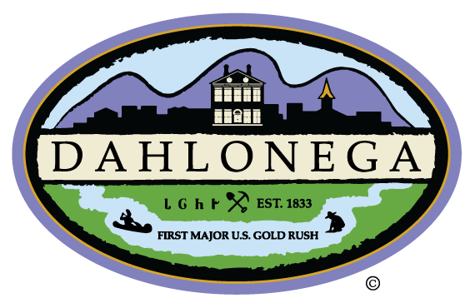
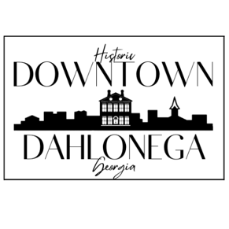
Extra Halloween Booth Application:

Name: _________________________________________ Date: ________________________

Company / Organization: ________________________________________________________

Primary Contact Person: __________________________ Phone: _________________________

Email: ___________________________________________

By signing this I agree to set up in the area designated to me by the Downtown Dahlonega Department. I agree to set up only during the length of the Halloween event. I agree to clean up my area when I am through.

Signature: ____________________________________________________________________

